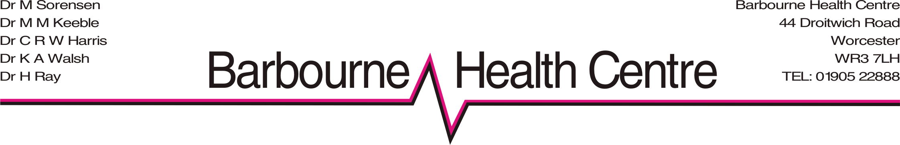

OCTOBER 2013

Healthy Outlook COPD Forecast Alert Service
The following information has been extracted from the met office web site, as this service has now been withdrawn, and you will no longer get any phone calls regarding weather changes.
“In light of the restructuring of the NHS commissioning process, introduced by the Health and Social Care Bill, and its subsequent impact on the take-up of our service, we have concluded that it is no longer viable for us to continue to provide Healthy Outlook.
Our Cold and Hot Weather Alert services to Public Health England and the Health Protection Agency and warnings are unaffected and will continue to be distributed through our website, and other media channels.
We will continue to work with healthcare organisations both in the UK and Europe to ensure weather and health research is progressed and new discoveries are found.”

General FAQ's

Why is the Met Office shutting down the Healthy Outlook service?
The Met Office has recognised that the health market increasingly requires a more tangible and significant cost-benefit that can be directly attributed to products and services during these times of austerity measures. This is something that is not possible with the design of the service that we have developed. Therefore, we have decided to withdraw this service from the UK health market.
Can I get this information from any other source?
Some companies do provide tele-health products that can help manage your condition. Useful sources of medical information are the British Lung Foundation and NHS Choices.

When will it be shut down?
The Healthy Outlook Service will be shut down at the end of your Primary Care Trust's / Clinical Commissioning Groups contract and will be finally closed down by the 30 November 2013.

Will you still provide any information to help me with my condition?
The Met Office will continue to provide its Cold and Hot Weather Alerts which are displayed on our website and through TV and radio channels, but we will not have any directly-related services for managing COPD available.

Where can I find this information?
You will see our Cold and Hot Weather Alerts on our website, the BBCs website and also on TV. We notify the Department of Health and media and news channels of the weather warnings to ensure that the public are aware.

