My

Annual Health Check

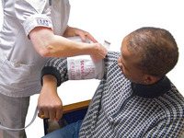

Name:

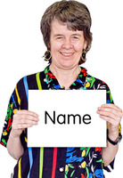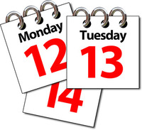

My date of birth: ……………………………………………

Date of my health check:………………………………



**Make sure you take this form to your health check!Fill in this page before you go to your health check. You can ask someone to help you with this.**

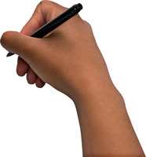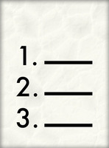

Things that have happened since my last health check.

Things that I want to ask at my health check.



**The doctor or nurse will fill in these pages at your health check**



I am tall

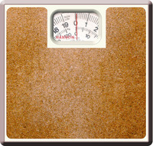

I weigh



My body mass index is



My blood pressure is



My health and breathing check shows that

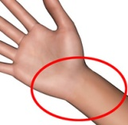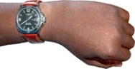

My pulse check shows that

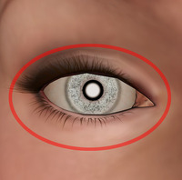

My eye check shows that

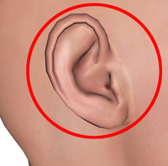

My ear check shows that

My tummy check shows that

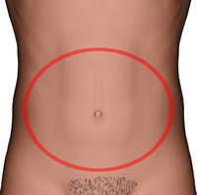

My feet check shows that

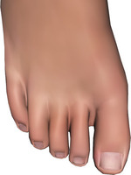

My walking check shows that

My wee check shows that

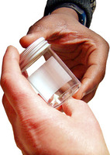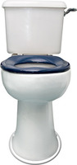

This is the help I need going to the toilet

I had a medication check and it was decided that

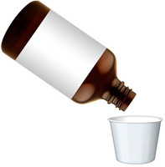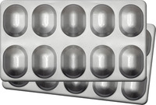

This is about my special health checks for women



This is about my special health checks for men



This is the advice the doctor gave me about keeping healthy

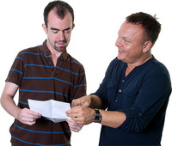

This is the support I need with keeping healthy



These are the things I do to keep healthy

Other important things about my health are

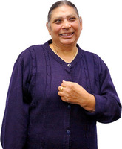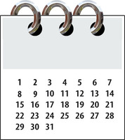

The date of my next appointment is

Easy Read form produced by SpeakEasy N.O.W. using Photo Symbols

